Standing Nesting Interface

ARC 4980

Contents

1. Introduction 3

2. Standard Nesting Interface Maintenance 3

2.1 Profile Maintenance 3

2.2 Export Maintenance 4

2.3 Import Maintenance 5

2.3.1 Work Center Maintenance 7

2.3.2 Import Settings 7

3. Export Interface 8

4. Import interface 9

4.1 Issue Waste to Indirect WO 10

4.2 Item Master for Inventory 10

4.3 Drops 11

4.4 Posting Labor and Material to GSS 11

5. Review Dashboard 12

# Introduction

The ARC 4980 Standard Nesting interface is a collection of GAB programs for interfacing Global Shop with several different nesting software. Currently, there are four main parts: the maintenance menu, the export menu, the import menu, and the nest information screen.

# Standard Nesting Interface Maintenance

Shop Floor Control > Administration > Standard Nesting Interface Maintenance

The Maintenance menu is for setting up the import and export mapping and options. This is typically a one time setup that will drive how the interface works.

## Profile Maintenance

Different profiles are set up in the profile maintenance screen, brought up by clicking the Profile Maintenance button. Here you can add and delete profiles. Different profiles can have different settings, mappings, and even work with different nesting software. The default profile is the one that will load first in the maintenance and export screen. If using unattended export, the default profile will be used.

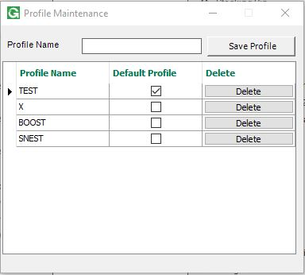

Once you have a profile set up, you can select it on the Export maintenance screen and configure it.

## Export Maintenance

The first step is to select an export type from the Export Type drop down. After that you can map the export. Click the Import Field List button at the bottom of the screen to bring up the Field list screen. Here you can enter in the list of field names you need in your export file, separated by commas. When done, click import, and the fields will be loaded into the field grid on the export maintenance screen.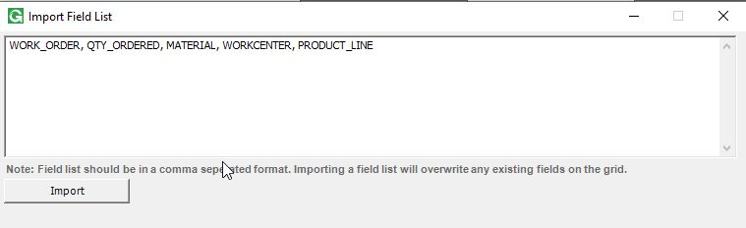

The Field Map Legend on the right can be used to view the Global Shop fields for a Work Order. You can select a work order sequence using the Labor Sequence browser and all of its fields will load into the legend. The numbers on the legend are the fields used for mapping in the grid.

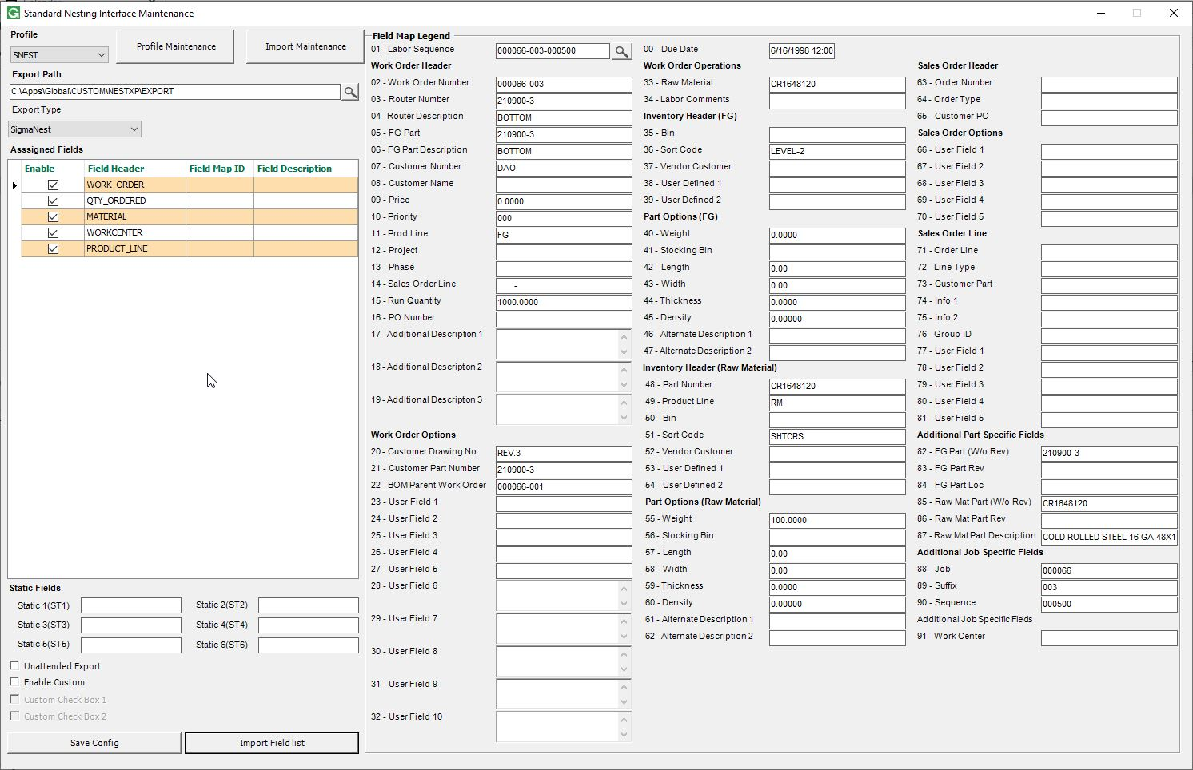

Mappings can be made by clicking the Field Map ID column in the grid and selecting a field from the drop down to map to.

The field description will load when you select a mapping. The static fields under the Fields grid can also be used for mapping. These fields are manually entered and will always be the same.

Select the file path to export to in the export path text box. This is where the export files will be placed.

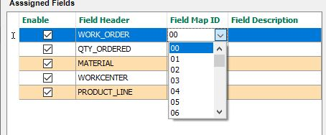If you’d like the export to run automatically, select the Unattended Export checkbox. The export script will need to be attached to the Post online update hook, 38130.

Depending on the export type, the Send Full .dxf File Name Instead of Part may be available. Checking this and giving the DXF file path will send the file name in the export instead of the part number.

Click save config to save the mapping and settings.

## Import Maintenance

Click the Import Maintenance button to open the import settings. Here you can import the import and remnant field list the same way as with the export field list.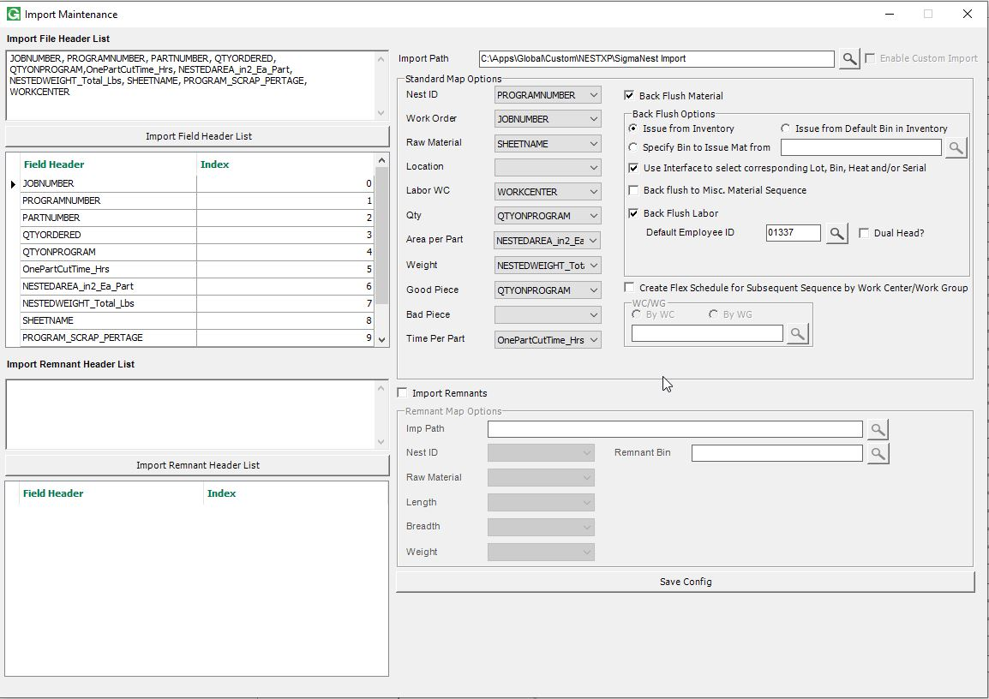

The path to import the files from is set in the Import Path text box. The mappings are set by selecting the grid field in the drop downs next to the field to map them to under Standard Map Options. If using an XML import file like OPS or Boost, the mappings will be disabled.

Check the Back Flush Material checkbox to issue material to the work orders when importing. This will enable the back flush options. Different options may be available based on the profile software.

Choose whether to Issue from Inventory, Issue from the default bin, or Issue from a specific bin that can be set in the text box. If you want to be able to select the lot, bin, heat, and serial when running the import, check the Use Interface to Select Corresponding Lot, Bin, Heat, and/or Serial checkbox. If you want to issue to the miscellaneous material sequence instead of the actual material sequence, select the Back Flush to Misc. Material Sequence check box.

To back flush labor, check the Back Flush Labor checkbox, and select the default employee in the default employee ID text box / browser.

If not backflushing labor, the Create Flex Schedule option can be used. This will create a flex schedule of the nested jobs for employees to clock into. When using this, you must select the WC or WG to create the flex schedule on in the box below.

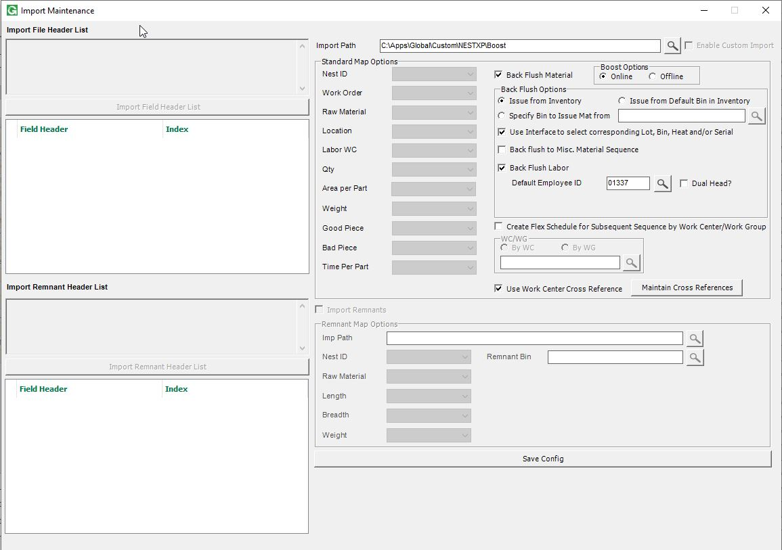

If using a Boost profile, there will be a Boost options box with an Online option and an Offline option. If Offline is selected, the JobFeedback report generated when the nest is created will be read. If Online is selected, the ProdSheetExp report generated when a sheet is finished will be read.

### Work Center Maintenance

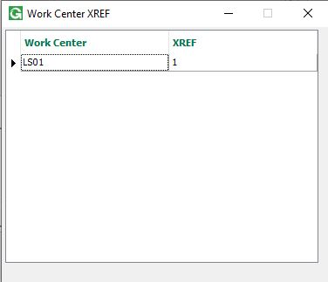Depending on the Import type, the Use Work Center Cross Reference option may be available. This is for if your workcenters are named differently in the nesting software than they are in Global Shop. To use this, check the option, then click the Maintain Cross References button to open the Work Center Cross Reference screen. This screen automatically populates with all work centers that have the Nesting Interface option checked in Estimating / Routing & Quote Management > File > Workcenter Maintenance > Open. You can add the Cross reference name in the XREF column. When importing, the work center names on the right will be tied to the GS work center names on the left.

### Import Settings

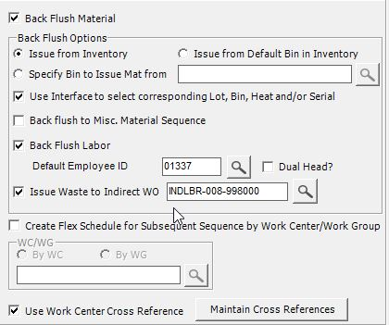Depending on the import type, the option Issue Waste to Indirect WO may be available. When checked, you can select an indirect work order in the text box/browser next to it. When import nests and backflushing material, the excess will be issued to this indirect Work Order instead of the material sequence on the nested work order. The material actually used for the parts will still be issued to the material sequence on the nested work order.

Click the Save Config button to save the import settings.

# Export Interface

Shop Floor Control > File > Standard Nesting Export Interface

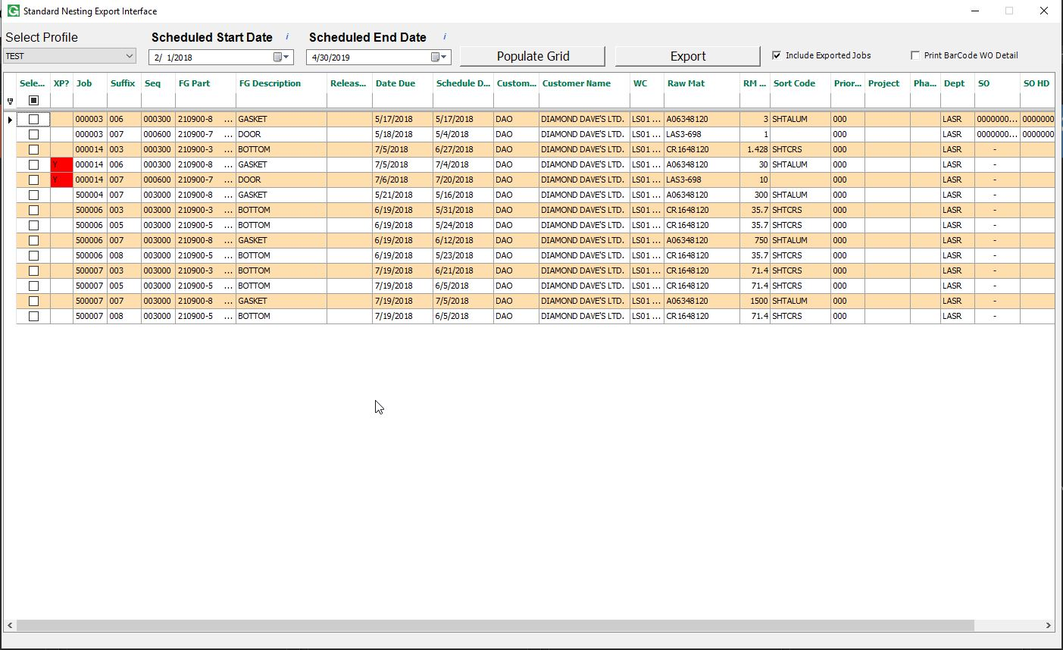

The export menu is for sending jobs from Global Shop to the nesting software that you’re using. Open the menu, and select the profile you’ll be using from the drop down. The profiles are set up in the maintenance menu and determine the settings and mapping that will be used for the export.

Select a date range and click Populate Grid to load the jobs that are available to be exported. Only job sequences on a workcenter that has the Nesting Interface checkbox checked on the Estimating / Routing & Quote Management > File > Workcenter Maintenance > Open screen will load. If the Include Exported Jobs checkbox is checked, jobs that have already been exported will load and be marked with a Y in the XP column.

Select the jobs you wish to export. Right clicking on the grid will allow you to select/deselect all rows or all filtered rows. Click the export button to export them. The export file will be generated based on the settings on the maintenance menu for that profile. If the Print Bar Code WO Detail box is checked, these will print as well.

# Import interface

Shop Floor Control > File > Standard Nesting Import Interface

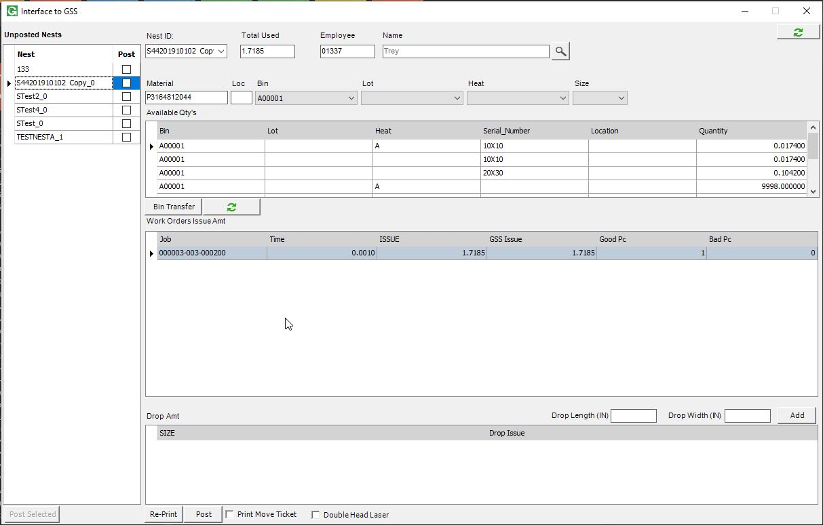The import menu is for importing feedback data from the nesting software or machines back into Global Shop. When a job is imported, the job is updated, pieces are claimed, and material is issued. When the import menu launches, it will check for new jobs to import from all profiles and network locations set up in the maintenance menu. They will load into the grid on the left of the screen.

A nest to import can be viewed by clicking on the row in the grid on the left, or by selecting it from the nest id dropdown. The information for that nest will load on the screen.

The Work Orders Issue Amt grid will show the work orders to import, and the time, pieces, and material used. The time column is in hours. The issue column is in the unit of measurement of the sheet material, and shows the amount of material used for parts. The GSS Issue column shows the (estimated) total material used for this job, including scrap, in the unit of measurement for the sheet material. This is the amount that will be issued to the work order. The GSS Issue column can change based on drops. The Total Used text box should always be the sum of the GSS Issue column added to the sum of the Drop Issue column, unless it is changed manually. It is rounded depending on the unit of measure.

## Issue Waste to Indirect WO

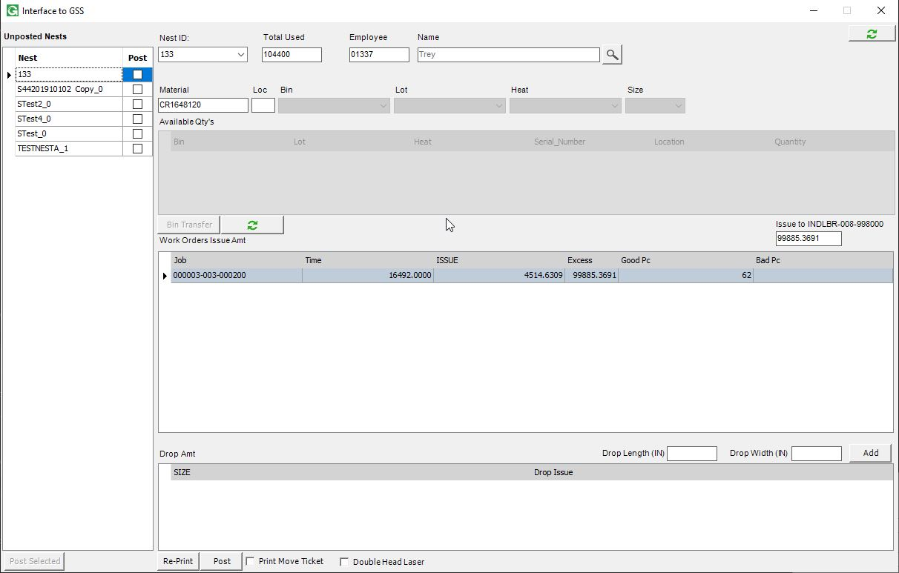If the Issue Waste to Indirect WO option is checked for the related profile in the import settings on the maintenance menu, the GSS Issue column will be replaced with an Excess column, which is the estimated waste from that work order. A text box will display above the work order grid with the sum of the excess column, and this amount will be issued to the indirect work order selected in the settings. The Issue column will be issued to the work orders in the work order grid instead of the GSS Issue column.

The default employee for the profile of the selected nest will load in the Employee text box. Enter in the employee number or use the Employee browser to change it. This is the employee that time will be applied to when backflushing labor. When posting multiple nests at once, this employee will be used for all of them.

## Item Master for Inventory

If the Use Interface to Select Corresponding Lot, Bin, Heat, Serial option is checked in the import settings for that nest’s profile on the maintenance menu, the bin, lot, heat, and size to issue can be selected from the dropdowns. The Available Qty’s grid will load the different options available, and change depending on the dropdown selections. Click the Bin Transfer button to open up the bin transfer menu to transfer material. Click the refresh button under the Available Qty’s grid to refresh it.

## Drops

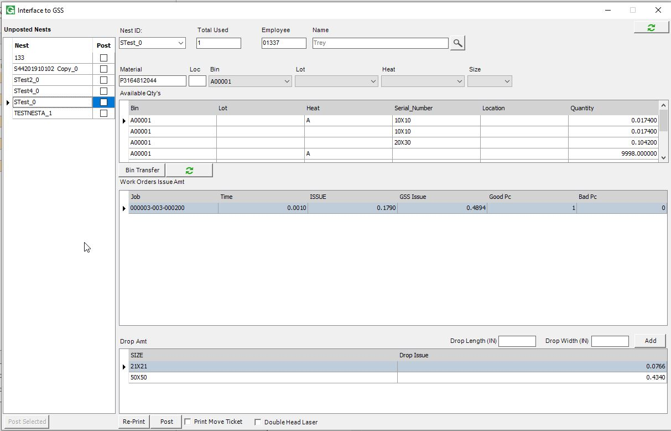The Drop Amt Grid will load in any drops reported by the nesting software/machine if the drop import is set up for that profile in the maintenance menu. If the Import Remnants checkbox on the import settings for that profile in the maintenance menu is checked, drops can be manually added to the drop grid. Enter the length and width in the appropriate text boxes in inches, and click add to add the drop. When a drop is added, the GSS Issue column on the work order grid will be updated, as well as the Total Used text box on the top right of the screen. Drop rows can be deleted by right clicking on the row in the drop grid and selecting delete.

## 4.4 Posting Labor and Material to GSS

Click Post to post the job, or select several jobs in the grid and click Post Selected to post all of them. By right clicking in the grid on the left, you can select/deselect all rows or all filtered rows, or group by parent nest.

The Re-Print button is for reprinting flex schedules of closed nests.

If the move ticket program is installed on your Global Shop, the option to print a move ticket will be available. Check this to print a move ticket for all updated jobs when posting.

Check the Double Head Laser checkbox if a double head laser is used. This will double material usage and claimed pieces.

When posting, the program will use the mapping and settings from the maintenance menu for that profile.

# Review Dashboard

Shop Floor Control > View > Standard Nesting Dashboard

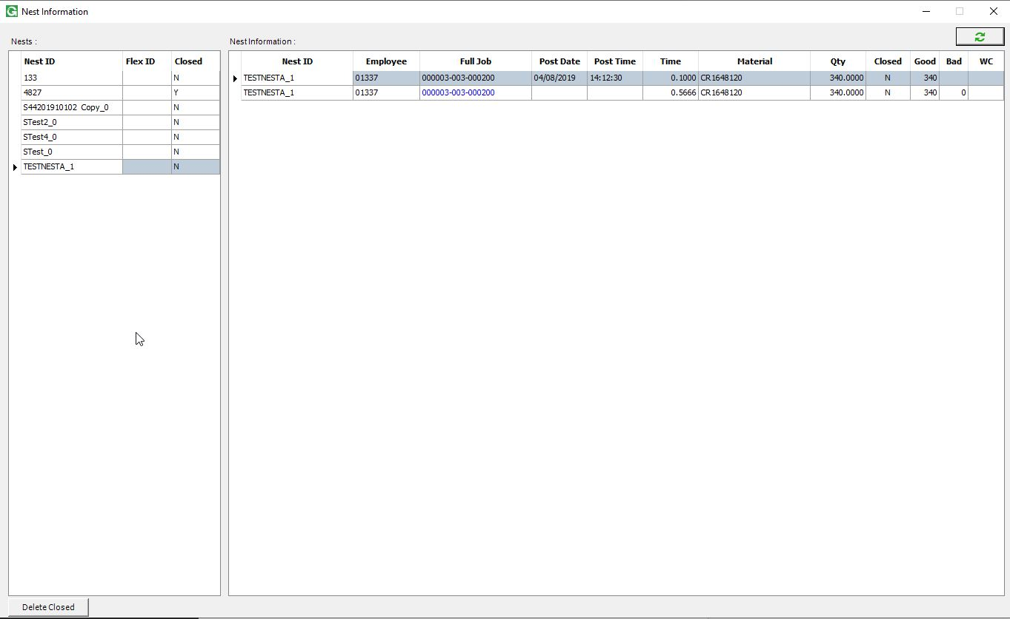

The Nesting Dashboard / Nesting Info menu is for viewing information on previous nests. The nests will load in the grid on the left, and when you double click on, it’s information will load on the right grid. You can double click the job number to be taken to the job in Shop Floor Control > View > Work Orders. If you right click on the Nest grid, you can reprint the flex schedule for the selected row, or delete the nest. The Delete Closed button will delete all nests marked as closed. Deleting a nest does not reverse the labor or material usage, it only removes the record of the nest from the Nesting Interface database.